**Statistical Learning Lab**

**Assignment - 1**

**Linear Regression Assignment**

**Show the code snippets and the corresponding output for the following:**

1. **Load the dataset “manufacturing.csv”. Display first few rows of the dataset.**

Ans: Uploaded dataset in R studio through “Environment-> Import Dataset”

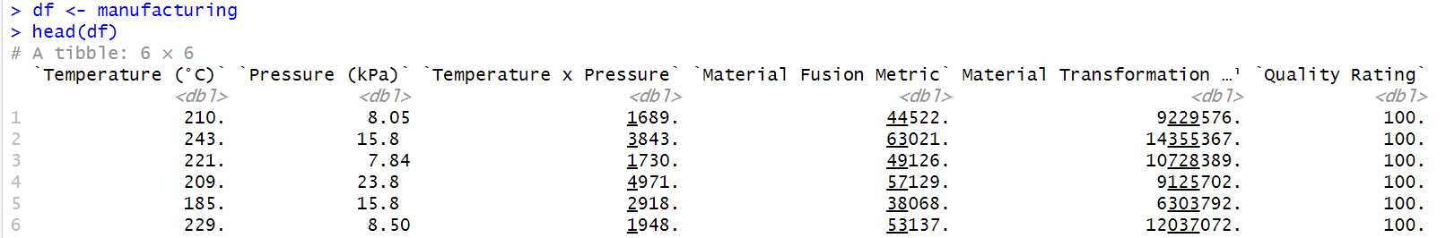

1. **Perform matrix plot and correlation analysis indicate if there is any correlation among the predictors**

Ans : Code to plot matrix scatter plot : plot(df)

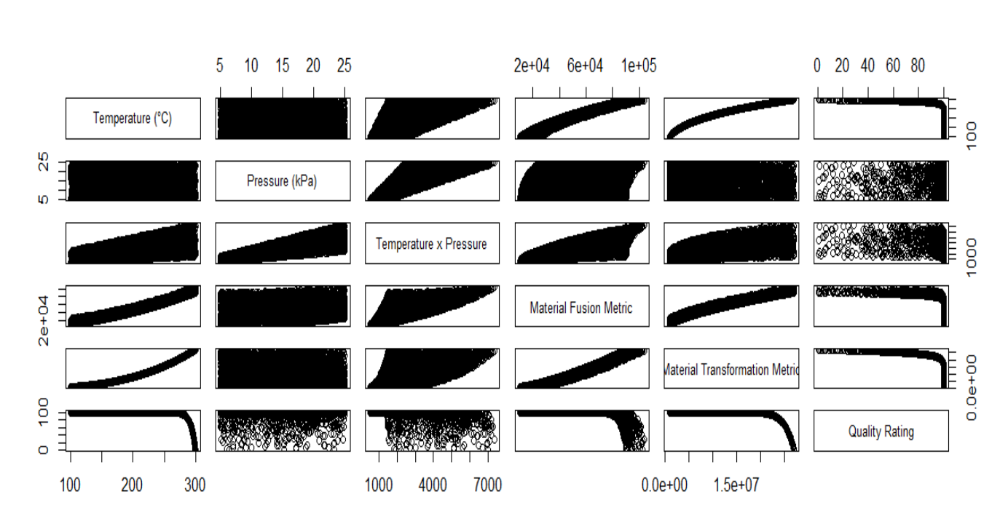

Observation from plot: From the charts we can say that ‘Material Fusion matrix’ is higly correlated with ‘Temperature’ and ‘Material Transformation matrix’ and also ‘Material Transformation matrix’ is highly correlated with ‘Temperature’.

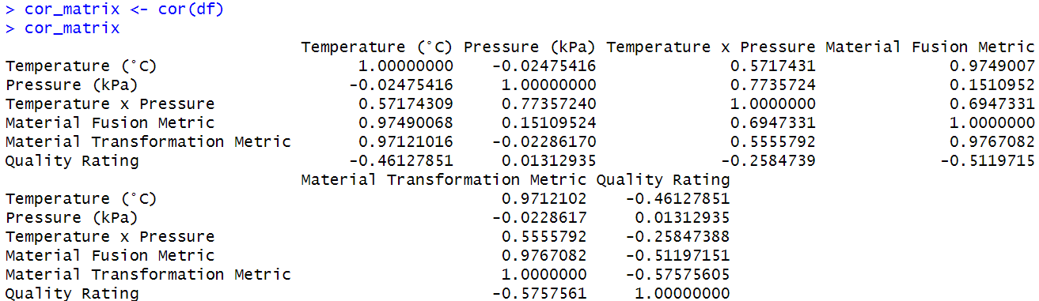

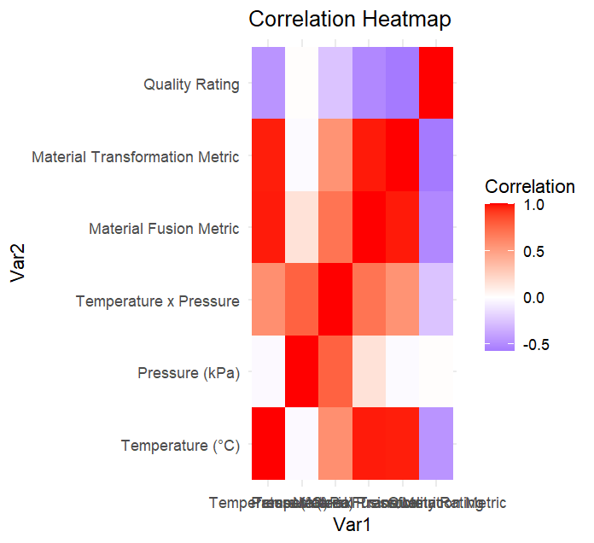

1. **Fit a Linear Regression model without the interaction term. From the linear regression summary which factors seem to be significant?**

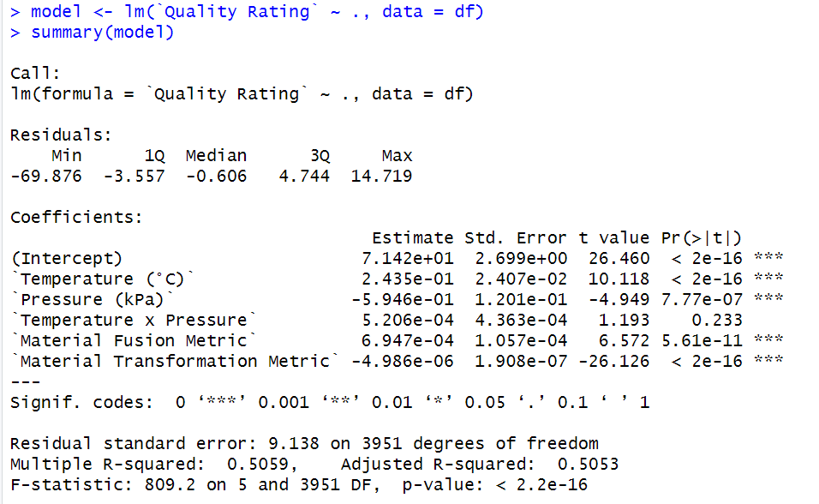

The features “**Temperature,Pressure , Material Fusion Metric, Material Transformation Metric”** are significant because the P values of these columns are less than 0.05.

1. **What is your interpretation R-sq and R-sq adjusted?**

Since, R-squared is 0.5 and R-sq adjusted is 0.5053 which is not a very good result . The remaining 50% is due to factors not included in the model or random error. This means only 50% of variance is explained by overall model.

1. **Perform normal probability plot of residuals and comment on model adequacy.**

So, for a good model , the normal probability should ideally be a straight line but it is curve. In this plot, significant deviations are observed, especially in the tails (at both ends). This indicates that the residuals are **not normally distributed**. So we can say that the model is not good and not adequate.

Code : resi <- residuals(model)

resi

qqnorm(resi)

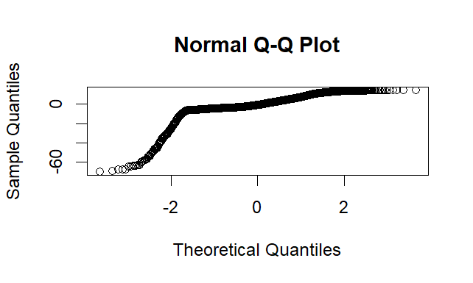

1. **Randomly sample 20% of the data and keep it as test data. Use rest of the 80% data to train the linear model. What is the RMSE on test data?**

